**Interim Technical Report**

**Sujit Malde ela17sm January 2020**

**Contents**

Project Description …………………………. 2

Project Aim

Project Specification

Background Theory and Methodology ……… 3

Loudspeaker Equivalent Circuits

Enclosure Design

Control Circuits

Methodology

Results ……………………………………… 9

SPICE Simulations

Bode 100 Impedance Analyses

Simulink System Simulation

Discussion and Evaluation ………………… 13

Discussion

Evaluation

References …………………………………. 15

Appendixes ……………………………. ….. 16

**Project Description**

**Project Aim**

E.R. Hanson stated in [1] that loudspeakers should be as small as possible, respond as linearly and across as much of the frequency spectrum as possible, to distort minimally, and to consume and emit power efficiently. The practical nature of conventional loudspeaker designs is such that this aim is difficult to achieve across the entire audible frequency spectrum. Hi-fi audio setups will therefore make use of multiple speakers, each responding adequately in a particular part of the audible frequency spectrum, to achieve a fairly linear response overall. The added complexity of multiple speakers and their associated crossover and filter electronics will vastly increase the price of such systems, relegating most consumers to inferior quality, single-speaker setups.

The worst-offending loudspeaker in the available range is the subwoofer – since it must move much larger amounts of air than woofers or tweeters, they are often much larger, more expensive, and more prone to distortions. In the sub-70Hz “sub-bass” range, performance is considered unreliable [2].

This project combines these two problems; the aim is to take a cheap subwoofer driver and explore open- and closed-loop compensation electronics improvements to its response, focusing on the sub-bass frequencies. The cost of such electronic solutions in combination with a cheap subwoofer system should be significantly cheaper than the price of a similarly performing, non-compensated existing system. Thus, the audio-conscious consumer would have a cheaper way of achieving better audio reproduction, companies could earn more profit from existing systems, and the compensation techniques could be applied to any system exhibiting similar physical properties as a loudspeaker.

**Project Specification**

* Theorise, simulate, and implement open-loop loudspeaker behaviour.
* Choose an open-loop compensation circuit suitable for a cheap subwoofer setup.
* Build a simple subwoofer setup and measure response before and after applying open-loop compensator.
* Design, simulate, and implement closed-loop compensators, comparing the subwoofer’s behaviour before and after adding them (time permitting).
* Final quantitative and qualitative assessment of compensated subwoofer performance versus an existing high-performance uncompensated system.

The specification has changed slightly from that introduced in the Project Initialisation Document – this is to reflect the slower-than-expected progress in the project. This is indicated by the ‘time permitting’ statement next to the closed-loop compensation specification point; after a discussion with my supervisor, it was suggested to refocus the project to at least prove that an open-loop compensation circuit provides better measurable results to a subwoofer’s performance, such that, if the worst case scenario of minimal progress were to occur, that there would at least be some results to present at the end of the project.

**Background Theory and Methodology**

**Loudspeaker Equivalent Circuit**

A loudspeaker may be modelled as two circuits which interact through a magnetic field. From a design perspective, this is a very powerful tool – a full electrical simulation for a subwoofer in a box can also be combined with compensation circuit simulations, which saves time and makes the design process much easier. The electrical circuit is the voice coil resistance *RE* and inductance *LE*. The mechanical circuit represents the mass of the cone and air, the spring property of the suspension, and the total mechanical damping effects as an equivalent capacitance *MMs*, inductance *CMs*, and resistance *RMs* respectively [3]. These two circuits are linked by a transformer that represents the back-emf/force constant, *Bl*, which represents the constant of proportionality between force on the cone and current through the coil. The work in [4] introduces a simple equivalent circuit model (Fig. 1).

$$L_{E}$$

$$Bl$$

$$R_{E}$$

$$V_{in}$$

$$I$$

$$V_{C}$$

*v*

Fig. 1 Simple loudspeaker electrical and equivalent mechanical circuit

$$C_{Ms}$$

$$M_{Ms}$$

$$R_{Ms}$$

$$F$$

In accordance with the introduced force-current proportionality, and with the intuition that, since all the mechanical parts of the loudspeaker are attached, they must share the same velocity, the simple circuit can be improved. Using standard techniques to refer values on the secondary of a transformer to its primary, the equivalent mechanical circuit parameters can be placed in parallel with the electrical circuit parameters, and the coupling effect may be removed from the circuit. Both improvements are shown in Fig. 2.

$$L_{E}$$

$$R_{E}$$

$$V_{in}$$

$$I$$

Fig. 2 Improved loudspeaker electrical and equivalent mechanical circuit

$$M_{Ms}{(Bl)}^{2}$$

$$\frac{C_{Ms}}{{\left(Bl\right)}^{2}}$$

$$\frac{{\left(Bl\right)}^{2}}{R_{Ms}}$$

An enclosure represents an additional mechanical resistance *RB*, since the loudspeaker is now affixed to a non-moving mounting face, which impedes more subtle movements than in the unmounted case. The compression of air behind the speaker that the box effectively stiffens the cone suspension, which is represented as an additional equivalent inductance *CB*. This represents the final additions to the equivalent electromechanical circuit that are actually relevant from a design perspective – any other additions would increase the accuracy of the model but only marginally, so it’s easier to just ignore these. Fig. 3 shows the final equivalent circuit used for the project.

$$L_{E}$$

$$R_{E}$$

$$V_{in}$$

$$I$$

Fig. 3 Final loudspeaker electrical and equivalent mechanical circuit

$$M_{MS}{(Bl)}^{2}$$

$$\frac{C_{MS}}{{\left(Bl\right)}^{2}}$$

$$\frac{C_{B}}{{\left(Bl\right)}^{2}}$$

$$\frac{{\left(Bl\right)}^{2}}{R_{MS}}$$

$$\frac{{\left(Bl\right)}^{2}}{R_{B}}$$

A full system block diagram for a loudspeaker is shown by Fig. 4 [5,6]. The electrical system forms a low-pass filter, whose cut-off frequency will lie above the frequency of operation. The mechanical system forms a band-pass filter – below its resonant frequency, for a subwoofer, the cone will be moving slowly but pushing a large volume of air, which requires large forces, and therefore large currents. Above resonance, less air is being moved but the cone moves faster; as the cone’s acceleration increases, the force and therefore the current required increases. To achieve this project’s aim, it is more important to satisfy below-resonance requirements as opposed to those above resonance. Of note in [4] is that, assuming that the force on the cone is non-linear, it can be shown that the effects of a non-linear cone suspension are stronger than at higher frequencies, legitimising further the choice of using a subwoofer as part of this project.

$$Bl$$

$$\frac{s}{k+sb+ s^{2}m}$$

$$V_{in}\left(s\right)$$

$$V_{in}\left(s\right)+E(s)$$

$$\frac{1}{R+sL}$$

$$Bl$$

$$I\left(s\right)$$

$$E\left(s\right)$$

$$v\left(s\right)$$

$$F\left(s\right)$$

+

–

$$I\left(s\right)$$

Fig. 4 Loudspeaker system diagram with coil current as the output

**Enclosure Design**

Loudspeaker driver manufacturers do not directly quote values for *MM, CM, RM* etc. because it is difficult to measure these values directly. Instead, a set of values known as Thiele-Small parameters (TSPs), described in [7]. These values are easier for loudspeaker driver manufacturers to measure and can be converted into an equivalent circuit by the user if necessary. They also give a viewer a more intuitive view of the driver’s performance – whilst the equivalent circuit parameters describe individually each aspect of the mechanical parts of the driver, the correlation between their variation and a change in the driver’s performance is not easily obvious.

Common TSPs stated by manufacturers are [7]:

* *fs* – the driver’s unmounted resonant frequency
* *RE* – voice coil DC resistance
* *QM* – driver mechanical circuit Q-factor
* *QE* – driver electrical circuit Q-factor
* *QT* – driver total Q-factor
* *VAS* – driver compliance equivalent volume (a volume of air having equal compliance as the driver’s suspension)
* *Znom* – voice coil nominal impedance
* *Bl* – back-emf/force constant
* *Sd* – cone surface area
* *Xmax* – maximum cone excursion from equilibrium
* *D* – cone diameter

With TSPs, the equivalent circuit for a loudspeaker can be derived, and a box’s compliance and mechanical resistance can be added into it.

It can be the case that an actual driver’s TSPs will vary from the nominal ones given on a data sheet; it therefore may be advisable to measure all TSPs manually for each driver.

**Control Circuits**

The four biggest sources of distorted sound reproduction are: over-excursion of the cone, high frequency noise in the input signal causing distortions, external noise, and changes to the cone’s suspension over time – the uncertainty of the loudspeaker’s physical properties changing over time. Removing erroneous high frequency sounds from the input signal is simple at the amplifier end by introducing a low-pass filter into the signal chain.

Controlling against noise and uncertainty is difficult due to the randomness of both, however the work in [6] describes the design and use of a disturbance-observer-estimator setup to control against disturbances to input signals from a measurement of the voice-coil’s current. Essentially, an estimated error signal is fed forward to the output of the system and subtracted from it, which in theory removes noise from the output. This method can be expanded to include an uncertainty-observer that estimates the change in uncertainty to the loudspeaker over time and subtracts this from the output as time goes on. The combination of these could mean that a loudspeaker remains linear over many years of its operation, in several different environments. The problem with this method is that the act of measuring the voice coil’s current will cause the output to be changed due to the existence of some form of sensor. A dual voice coil (DVC) loudspeaker would be useful in this case, as one voice coil could be left untouched and used to drive the cone, whilst the other could be used for sensing.

Controlling the cone from over-excursing requires a measurement of displacement, or some derivative thereof. One method of obtaining these is discussed in [8]. The author describes attaching a variable capacitor (varactor) to the cone. This varactor would be connected to a Clapp oscillator which would generate a frequency-modulated encoding of the cone’s displacement in time when compared to a phase-lock-loop circuit [9]. Another method is described in [10], using a traditional accelerometer setup. The focus of [10] is more on how the presence of an accelerometer changes the output sound, which is unavoidable as it is impossible to have a ‘sensing’ loudspeaker cone. The effect of any sensor on the output sound should be considered equally as important as the effects of the sensor and its associated control circuitry, to ensure that any benefits brought by the control circuitry isn’t undone by any electromechanical distortion or damping.

**Methodology**

The methodology that was undertaken in the project thus far shall now be described. All SPICE models used are given in the Appendix.

1. Firstly, a driver was selected. For this project, the Pyle PLPW6D was chosen partly for its cheapness, but also because it features two voice coils. This dual voice-coil (DVC) setup could be used for a driving/sensing setup, where one voice coil drives the cone, and another provides the control circuitry discussed above with a reference signal. Therefore, the act of sensing would not impede upon the act of driving. The TSPs supplied in its datasheet [11] are given in the Appendix. On the datasheet can also be found the manufacturer’s impedance plot for the driver, which shall be referred to henceforth as the **datasheet plot.**
2. As the arrival of the drivers from the supplier was awaited, background research and initial simulations of electrical circuits occurred. As can be seen from the PLPW6D’s TSPs, some calculations were necessary to find *Bl* and *CMS, MMS, RMS*. These equations, laid out in [7], along with common circuit analysis techniques, were used to derive the equivalent circuit:
   1. It was initially assumed that the amplifier’s output impedance was a necessary component in the equivalent circuit. Whilst it is true that amplifiers feature non-linearity and distortion, these effects are orders of magnitude lower than those for the loudspeaker, and so the amplifier could be ignored.
   2. The voice coil’s inductance was initially erroneously derived from the resonant peak of the datasheet plot. After the error was identified, it was then estimated from the impedance at 20kHz of the datasheet plot – at high frequencies for an RL low-pass filter, only the inductor will define circuit behaviour.
   3. The most important TSP that required calculation was *Bl*, as all equivalent circuit parameters are dependent on it. However, *CMS* can be calculated first as it only depends on *VAS*, which was given:

(1)

* 1. *Bl* could then be calculated using:

(2)

* 1. At the driver’s resonant frequency, only the equivalent mechanical capacitance and inductance would define the circuit. Therefore:

(3)

* 1. *RMS* could then be derived from the mechanical circuit and its Q-factor:

(4)

* 1. From the relationships seen in Figs. 2 and 3, the electrical equivalent values were derived, and the circuit was simulated in SPICE using these values:

$C_{MS}^{'}=23.9mH$ $M_{MS}^{'}=388.95μF$ $R_{MS}^{'}=28.42 Ω$

It should be noted that the methodology from this point onwards is flawed – this will be discussed after the results section of this document.

1. The Linkwitz Transform [12,13] was chosen as the best open-loop compensator for the subwoofer system. This is because it not only extends the bass response for a subwoofer, but also reduces the group delay of the system, meaning that the driver responds faster to an input signal, reducing potential lag between different parts of the audio reproduction signal chain. Traditional equalisation methods revolve around introducing electronically a pair of zeros to cancel out undesirable poles in the frequency response to try and flatten it. Further detail is given in the appendix. There are two methods of designing a Linkwitz Transform for a system:
   1. Using the original formulas laid out by the transform’s late designer [12].
   2. Using resources available from the late designer’s website [13] that automate the process of designing and optimising the circuit for a system.
2. Many hours were spent on optimising the Linkwitz Transform for the simulated circuit. Many different values were given to the design tools available to try and ascertain a perfectly flat response that still gave a reduction in group delay. Eventually, one circuit topology was chosen:
3. Impedance measurements for each voice coil were taken using a Bode 100 Impedance Analyser. Connections were made across each voice coil, as well as across the voice coils to ensure that there was no electrical coupling between the two. The resulting impedance plots were used to verify the calculated inductance of the voice coils.
4. A design for a box commenced. Putting a driver into a reasonably sized box is guaranteed to increase its resonant frequency, because the air behind the driver is sealed in the box and therefore has a compliance. The air can be thought of as a spring, stiffening the driver’s suspension – below resonance, adequate power is required to overcome this spring.
   1. It is best to choose a new resonant frequency for the driver-box system and ascertain the power requirements for the system at that point.
      1. This can be done by ascertaining the acceleration of the cone at this frequency:

(5)

* + 1. Given this acceleration, the force required to accelerate the mass of the cone can be found, and this can be converted into a current through *Bl*. Since the excursion must not exceed *Xmax­*, the calculated force may be considered as a peak force, so the equivalent current can be considered a peak current *Ip*.
    2. This peak current may be converted into a power amplifier requirement given the impedance of the voice coil as seen in the specification:

(6)

* 1. By definition, the driver can only excurse to *Xmax­* given the calculated peak force, which is equivalent as saying that the box has a certain compliance – a certain amount of excursion per Newton. Thus, a new box compliance is derived.
 $$C_{B}=0.17 mm/N$$

 2. This compliance can be converted through *Bl* into an equivalent circuit parameter, and into an equivalent volume of air using (1). This volume is the volume of the inside of the box.

$$Vol=5.74 litres$$

The box resistance is large enough such that when combined in parallel with *RMS*, it barely alters *RMS*. Therefore, it may be ignored if sufficiently large.

* 1. Some further simple arithmetic can be conducted to form the dimensions of the exterior of the box, given a material thickness. This whole process was automated using MATLAB, the code for which is given in the Appendix.
  2. The box was modelled in Autodesk Fusion 360 to ensure visually that the driver would fit inside it, and that the dimensions seemed reasonable.

1. A Simulink model was created to ensure that *Xmax* would not be disobeyed, given a certain size of box. To derive *Xmax*, the current through the capacitor was measured – this current is analogous to the force on the moving mass of the subwoofer through *Bl*. Dividing this force by the mass of the cone *MMS* gives the acceleration of the cone in time, so a double integral yields the displacement of the cone from equilibrium at that point in time. The implementation of this simulation is shown in Fig. 5. This validated the theory and code described in part 5 of this section.

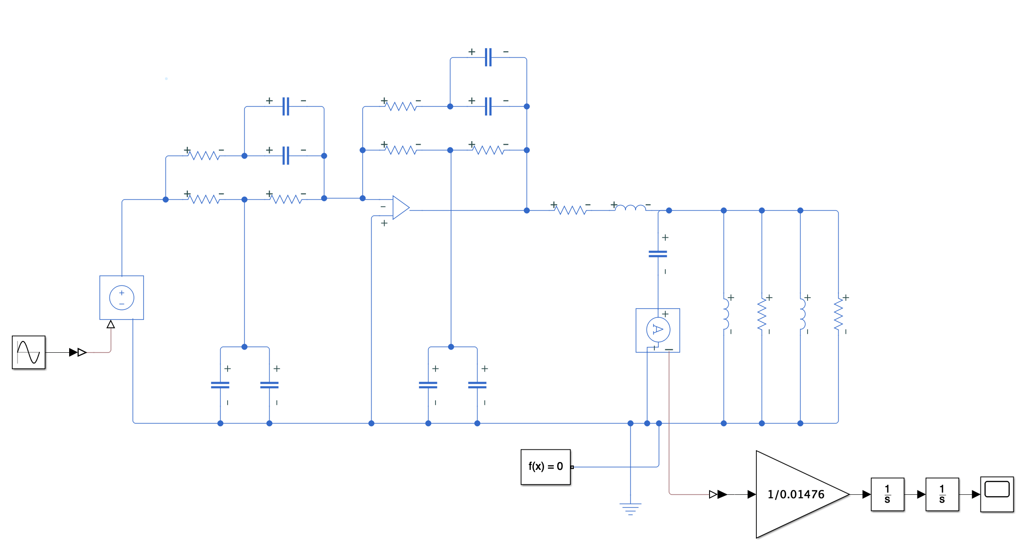

Fig. 5 Simulink model for loudspeaker in enclosure to simulate and plot cone excursion

1. The enclosure for the subwoofer was then manufactured. The chosen material for the enclosure was 12mm thick medium density fibreboard (MDF) – this was chosen due to its strength and density, necessary as pressures inside the box during subwoofer operation are similar to those that push the required amount of air to generate bass sounds. The walls of the enclosure were laser cut from the dimensions in its 3D design, with an extra circular hole cut out of the front panel to accommodate the driver. Smaller holes were cut on the back to mount banana plugs to the enclosure.
   1. Assembly involved gluing all the sides together bar one (to allow access to the inside of the box) using PVA, then securing the joints with screws.
   2. A pillar drill was used to cut any screw pilot holes, and a hand drill used to drive the screws into the holes.
   3. In this manner, holes were drilled to allow the driver to be screwed onto the front panel.
   4. Then, all the inside joints were sealed with silicone sealant, wires soldered to the spade terminals and affixed to the mounted banana plugs.
   5. Then the final panel was glued and screwed on.

All of these steps ensure that the box can withstand the pressures generated by the driver, and that there are no air gaps which would cause irritating whistling noises and disturb all electronic compensation theory up to this point.

**Results**

**SPICE Simulations**

Fig. 6 compares the magnitudes of the unmounted, mounted, and mounted-transformed frequency responses of the Pyle PLPW6D. The addition of an equivalent enclosure increases the resonant frequency of the system according to the value given to the MATLAB box designer script. The Linkwitz Transform extends the response of the system well into the sub-bass frequencies, with a flat response from 100Hz down to 10Hz with a gentle roll-off. Figs. 7 and 8 show the comparisons of phase responses and group delays respectively. The group delay gives an insight into the delay of an input signal’s propagation through each system in the critical 10-100Hz region of operation.

**Bode 100 Impedance Analyses**

The impedance plots for each voice coil of each speaker followed the shape of the datasheet plot. The resonant frequencies lay at around 70Hz for each, which would slightly alter the calculated value of *Bl*. The speaker out of the three that were purchased that will be mounted into an enclosure is henceforth referred to as ‘Speaker 3’, and its impedance analyses plots are shown in Figs. 9 and 10.

**Simulink System Simulation**

Fig. 11 shows the results of the Simulink simulation of this mounted and Linkwitz-Transformed system given the peak voltage input into the system based on the power amplifier rating calculated using (6), at 20Hz.

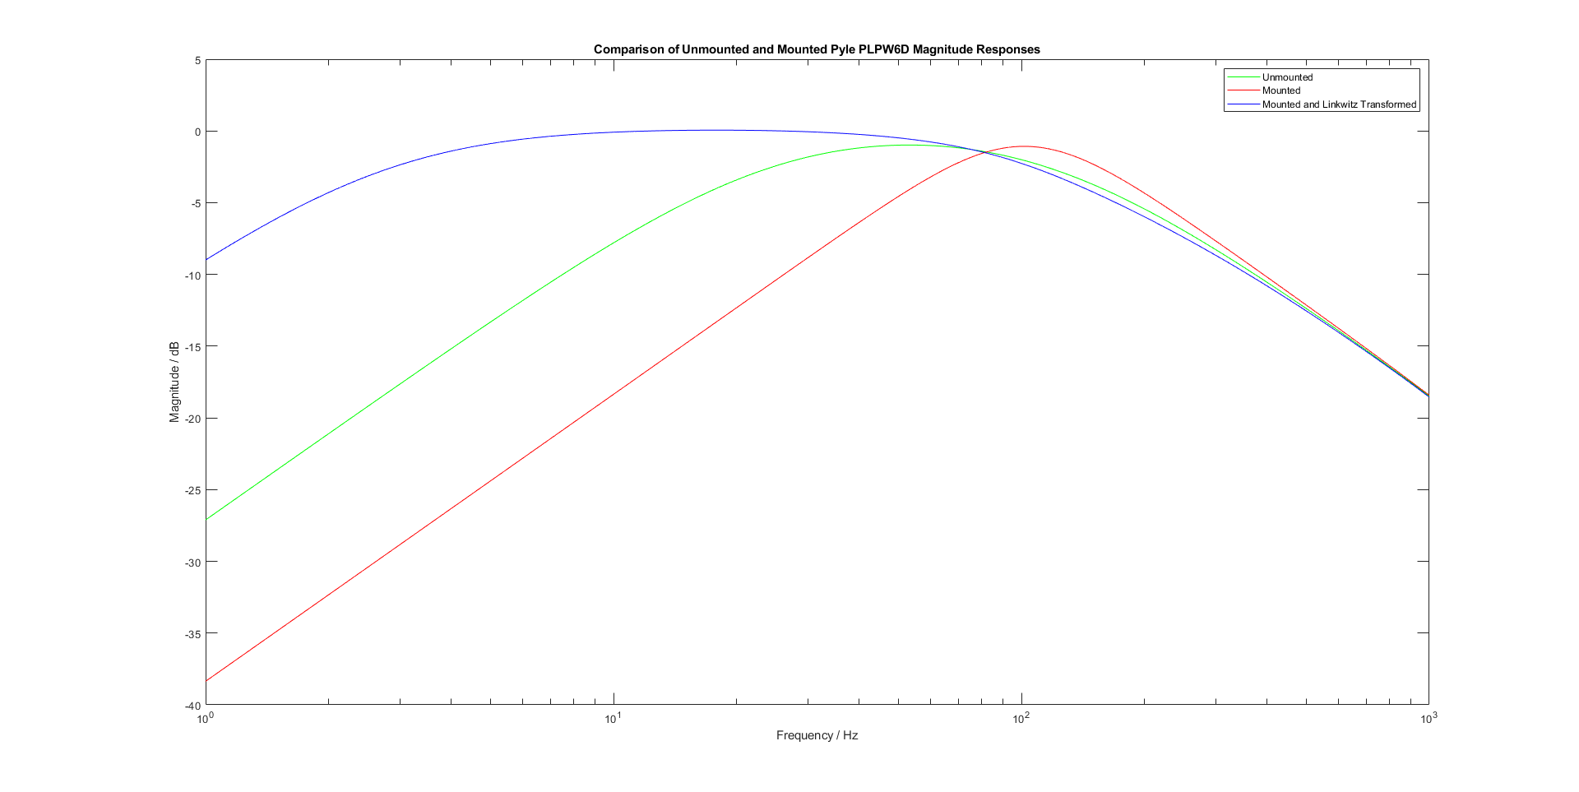

Fig. 6 Simulated Pyle unmounted, mounted, mounted with Linkwitz Transform magnitude responses [14][15]

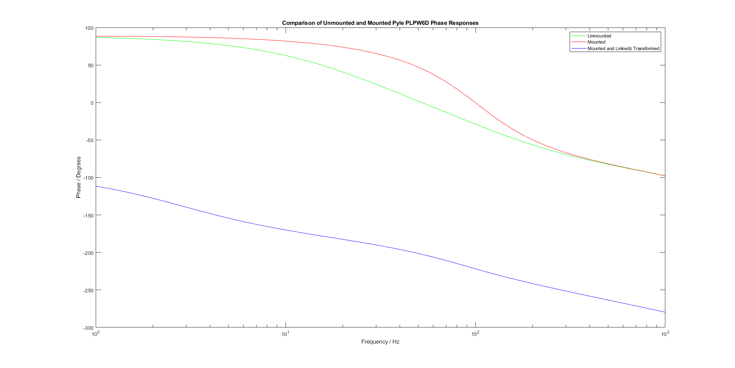

Fig. 7 Simulated Pyle unmounted, mounted, mounted with Linkwitz Transform phase responses [14][15]

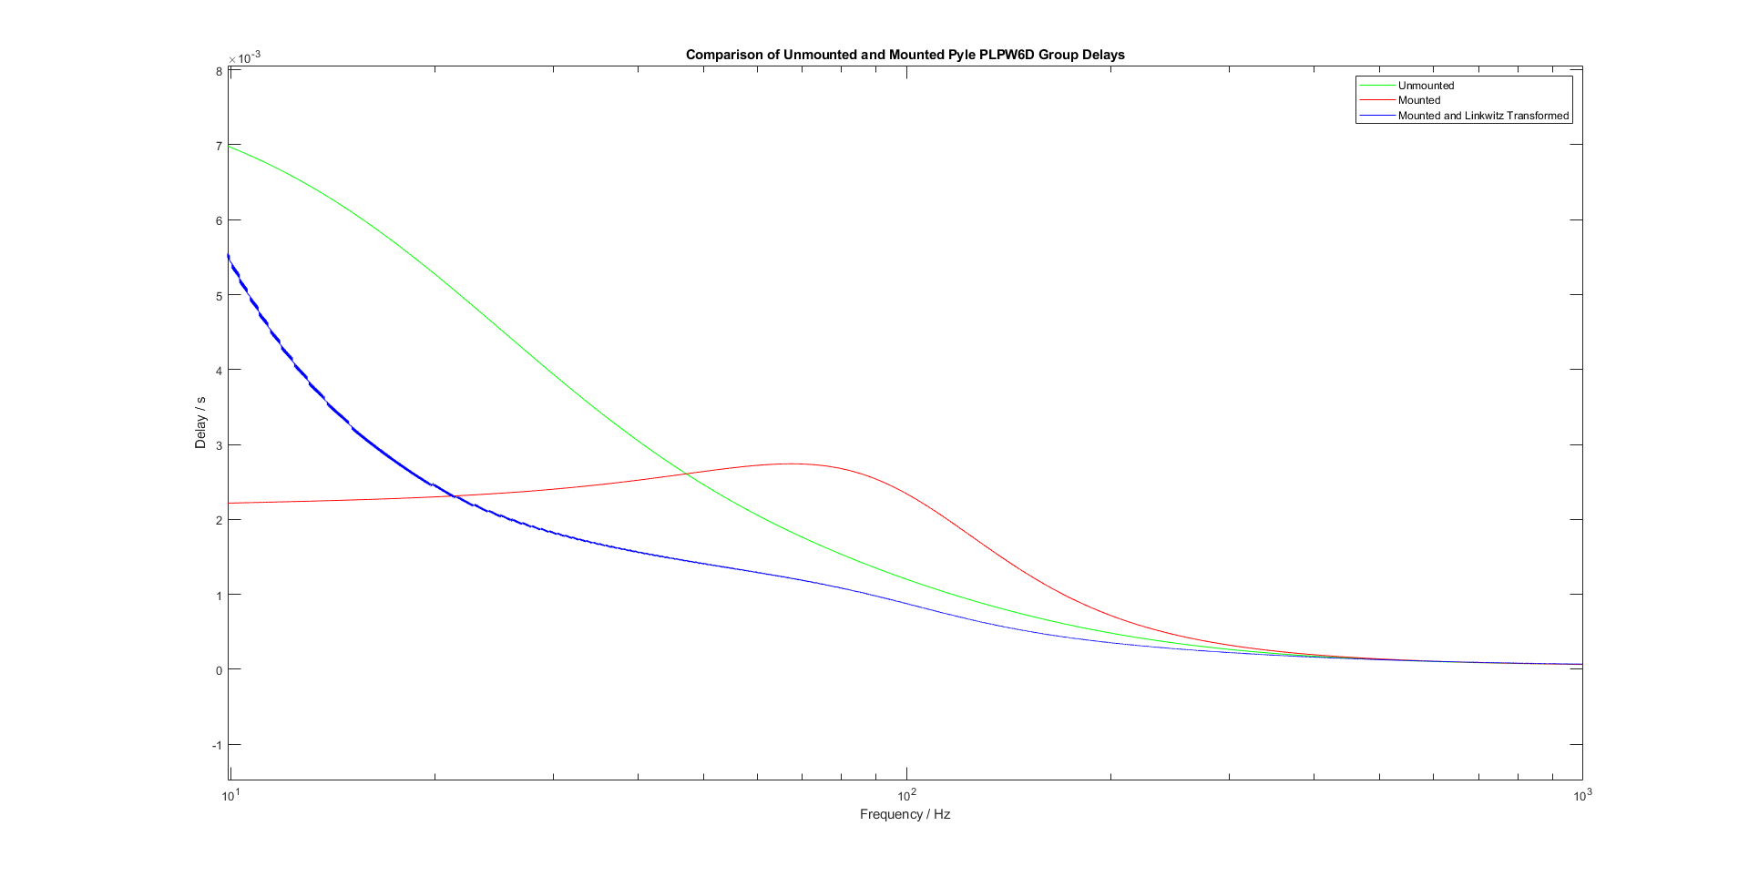

Fig. 8 Simulated Pyle unmounted, mounted, mounted with Linkwitz Transform group delays [14][15]

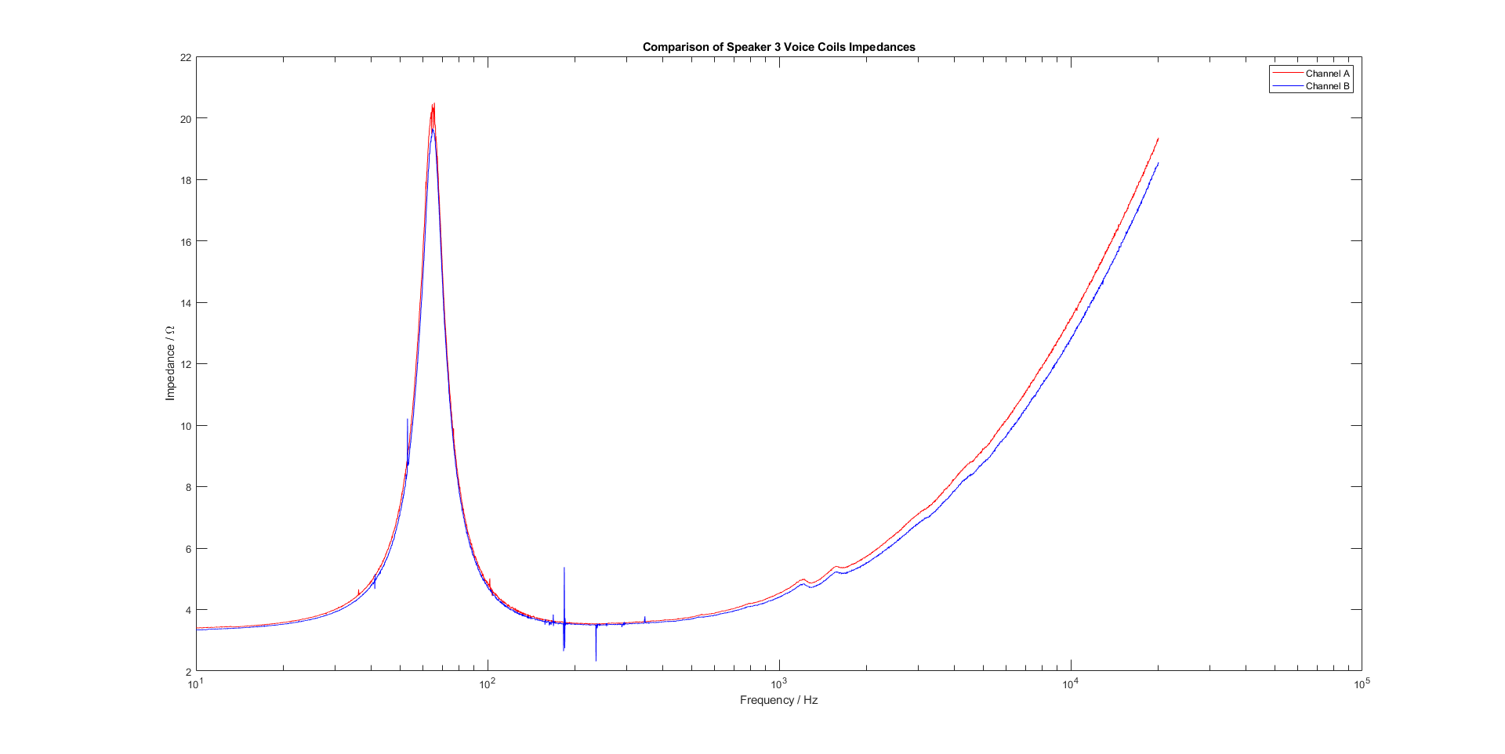

Fig. 9 Measured impedances for each voice coil of Speaker 3 [14][15]

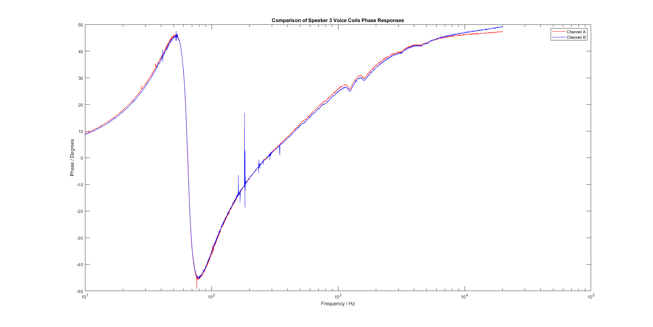

Fig. 10 Measured phase responses for each voice coil of Speaker 3 [14][15]

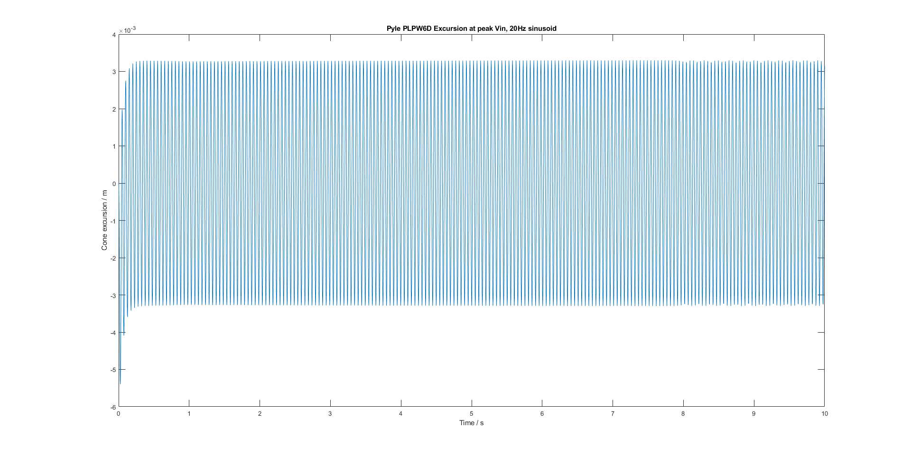

Fig. 11 Results of Simulink model to determine cone excursion under ‘worst-case’ subwoofer operation scenario [14][15]

**Discussion and Evaluation**

**Discussion**

The results of the impedance analyses show that the design for the box is too small for the original poweramp requirement, as the magnet cannot actually generate enough force to overcome the decreased compliance of the box. However, this is easily rectified by simply increasing the power delivered to the speaker, which is acceptable since the original power requirement was so modest.

Measuring across separate voice coils lead to a massive impedance measurement, implying the existence of a dielectric, thereby confirming that the voice coils were independent from one another. The perceived error in impedances and phase responses between the two for the selected subwoofer is small enough such that no correction circuitry is required, so the driving-sensing setup discussed earlier can be undertaken with confidence.

The results of the SPICE simulations prove that the Linkwitz Transform not only increases the magnitude of response at sub-bass frequencies, but also improves the group delay of the subwoofer system in the range of operation. This means that adding the transform would enable the subwoofer to produce more bass, more linearly, and with less of a lag from when an input voltage is applied to it. The latter analysis shows that this subwoofer system would be appropriate to transplant into a full sound system instead of existing as a stand-alone research item.

The current Linkwitz Transform circuit is not optimised well for a real-world subwoofer. Under 20Hz, massive current and cone excursion requirements render accurate sound reproduction difficult, with risk to the physical integrity of the system high.

The Simulink simulation may be considered a ‘worst-case’ scenario for the system’s operation – at low frequencies the cone must move the furthest to move the required volume of air to reproduce the driving frequency. Nevertheless, it is clear that the cone excursion does not exceed 4mm from equilibrium in either direction of its travel once the system is stable. This Simulink model could be used further into the project to test the validity of closed-loop circuits.

Frequencies lower than 20Hz were not considered worth simulating given that most recordings do not contain sound data below 20Hz. The action of one closed-loop controller will be to limit the cone’s excursion to avoid damage to the system and distortion to reproduced sound.

**Evaluation**

All results currently exist as simulation data. This can be considered as a shortcoming of the progress thus far, as physical systems and results will always differ from experimental results. Too much time has been spent simulating the systems instead of actually building and measuring the systems. Although it is not clear to find one easy way to build the perfect enclosure, a decision should have been made much earlier into the project, in order to have a system to work with to create novel electronic solutions. What should have been a precursor activity to the bulk of electronic work has now taken over the project as the bulk of the work. This puts into jeopardy the possibility of finding and implementing closed-loop control circuits. A better methodology for the project up to this point shall be briefly detailed:

1. Create loudspeaker equivalent circuit from datasheet values whilst waiting for subwoofers to arrive.
2. Conduct impedance analyses on subwoofers and edit equivalent circuit to reflect real-world values.
3. Derive box dimensions using equivalent circuit theory.
4. Build box and mount subwoofer.
5. Measure frequency response of system in anechoic chamber and take new impedance measurements.
6. Use measured frequency response to design and tune Linkwitz Transform circuit.
7. Measure new frequency response of subwoofer with Linkwitz Transform.

The progress thus far has nonetheless solidified a clear build plan for a well-performing subwoofer, with extra steps taken to automate and validate the process as much as possible. The principles of iterative design, and of verification and validation, were displayed.

The project was not conducted with enough respect to the original Gantt chart, which lead to constant intervention and guidance from the supervisor being necessary to stay on track. The learning from these mistakes should, however, bolster the progress in the next stage of the project. Fig. 12 shows an improved Gantt chart for the rest of the project’s duration, along with the key.

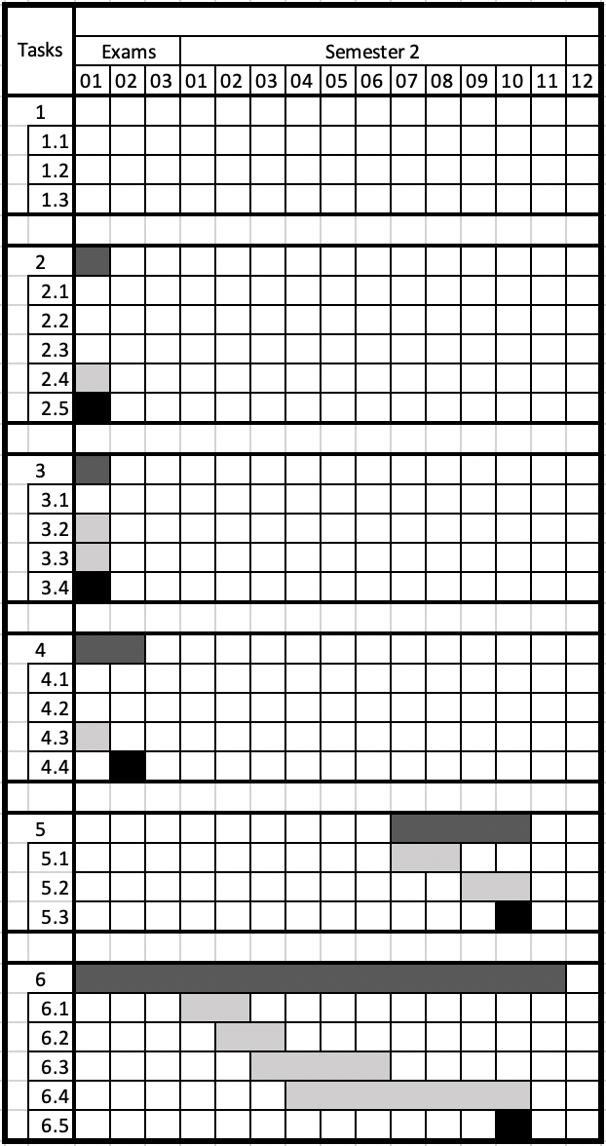

Fig. 12 Amended project Gantt chart

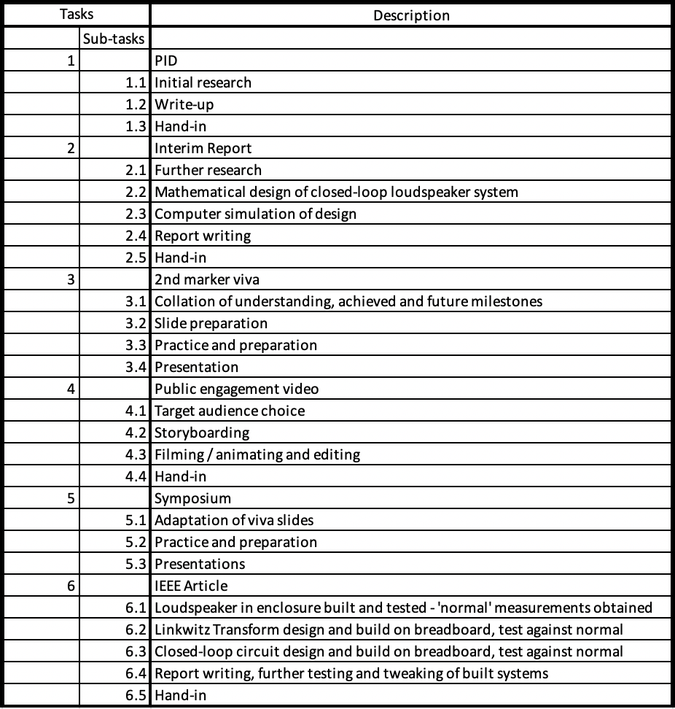

Fig. 13 Amended project Gantt chart key

The amended Gantt chart assumes that three weeks is sufficient time with which all open-loop design, building, and measurement can be completed. Due to the familiarity gained with the process of designing a Linkwitz Transform, this is a reasonable estimate. The circuit will initially be built on breadboard for easy tuning before committed to stripboard. Designing and building a PCB for the circuit would be ideal in order to limit noise, but given that the project is behind schedule, it is probably not a good use of time and effort for the coming weeks. The frequency of operation of the circuit is low enough to justify the use of bread/stripboard.

**References**

1. E. R. Hanson, “A motional feedback loudspeaker system,” in *Audio Engineering Society Convention 46,* Audio Engineering Society, 1973.
2. F. Rumsey and R. McCormick, *Sound and Recording,* 5th ed. Oxford: Focal Press, 2006.
3. H. F. Olson, *Elements of* *Acoustical Engineering,* New York: D. Van Nostrand Company, Inc. 1940.
4. F. X. Y. Gao and W. M. Snelgrove, "Adaptive linearization of a loudspeaker," *[Proceedings] ICASSP 91: 1991 International Conference on Acoustics, Speech, and Signal Processing,* Toronto, Ontario, Canada, 1991, pp. 3589-3592 vol.5.
5. J. Catrysse, “On the Design of Some Feedback Circuits for Loudspeakers,” in *Audio Engineering Society*, vol. 33, Audio Engineering Society, June 1985.
6. Yaoyu Li and G. T. Chiu, "Control of Loudspeakers Using Disturbance-Observer-Type Velocity Estimation," in *IEEE/ASME Transactions on Mechatronics*, vol. 10, no. 1, Feb. 2005.
7. smalls_closed_box_article_2_OCR
8. J. Catrysse, “On the Design of Some Feedback Circuits for Loudspeakers,” in Audio Engineering Society, vol. 33, Audio Engineering Society, June 1985.
9. P. Horowitz and W. Hill, The Art of Electronics, 3rd ed. New York: Cambridge University Press, 2015.
10. H. Schneider, E. Pranjic, F. Agerkvist, A. Knott, M. A. E. Anderson, “Design and Evaluation of Accelerometer based Motional Feedback,” in Audio Engineering Society Convention 138, Audio Engineering Society, May 2015.
11. <https://www.pyleaudio.com/sku/PLPW6D/65-600-Watt-Dual-Voice-Coil-4-Ohm-Subwoofer>
12. Speaker Builder 1/86
13. Linkwitzlab
14. *Simulink.* (Version 10.0, R2019b). Mathworks, 2019.
15. *MATLAB.* (R2019b Update 1, 9.7.0.1216025). Mathworks, 2019.
16. *LTspice XVII.* (Build Oct 13 2019). Mike Englehardt, 2019.
17. TL074 model
18. Small’s Closed Box analysis
19. TL074 datasheet

**Appendixes**

**A – On the Linkwitz Transform [12] [13]**

The Linkwitz Transform works upon a fundamental analysis in [18] that shows that the frequency response of a loudspeaker in a closed box will resemble that of a second-order high-pass filter. The transform essentially moves the cut-off frequency of this response by cancelling the existing poles and zeroes in the response and re-introducing them lower in frequency. This results in an extension of the frequency response below that which normally occurs. The transform should be designed such that a roll-off in frequency response ideally begins to occur at 20Hz; this ensures that sub-bass frequencies are heard and boosted, but without causing the speaker to excurse dramatically, avoiding the risk of damage to it. The general topology of the circuit is as shown:

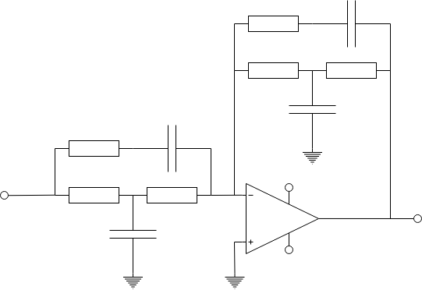

$$V_{in}$$

$$V_{out}$$

$${+V}_{s}$$

$${-V}_{s}$$

$$R_{2}$$

$$R_{2}$$

$$R_{1}$$

$$R_{1}$$

$$C_{2}$$

$$C_{2}$$

$$C_{1}$$

$$C_{3}$$

$$R_{3}$$

$$R_{3}$$

Fig. 14 Linkwitz Transform topology [12][13].

In order to build the required circuit using common component values, it may be necessary to split the capacitors shown into two capacitors in parallel. The process of building the circuit with appropriate, common component values is possible using resources available from [13].

**B – MATLAB script to design loudspeaker enclosure [15]**

%%%%%% USER EDITS GO HERE %%%%%%

%%% SPECIFICATION BLOCK %%%

% Add loudspeaker Thiele-Small parameters here

Cms_spec = 0.00063

Bl_spec = 6.16

VAS_spec = 15.38

fs = 52.2

Xmax = 0.004

Mms = 0.0148

Z_nom = 4

speaker_face_diameter = 0.165 % Also known as Sd

% Select MDF thickness and define mounting face dimensions

mdf_thickness = 0.012

mounting_face_length_ext = 0.200

mounting_face_width_ext = 0.200

% Choose new resonant frequency

f_above = 100

%%%%%% USER EDITS END HERE %%%%%%

a_above = (2*pi*f_above)^2 * Xmax

F_above = Mms * a_above

Ip_above = F_above / Bl_spec

poweramp_above = (Ip_above/sqrt(2))^2 * Z_nom

%%% Ideal box size for Xmax = 4mm

Ip = sqrt(poweramp_above / Z_nom)*sqrt(2)

F_req = Ip * Bl_spec

Cms_box = Xmax / F_req

VAS_box = (Cms_box / Cms_spec)*VAS_spec

V_box = (VAS_box*VAS_spec)/(VAS_spec-VAS_box)

%%% BELOW RESONANCE POWER REQUIREMENTS %%%

VAS_box = (VAS_spec * V_box)/(VAS_spec + V_box)

Cms_box = (VAS_box/VAS_spec) * Cms_spec

fb = fs*sqrt(VAS_spec / VAS_box)

F_req = Xmax / Cms_box

Ip = F_req / Bl_spec

P_diss = (3.4 * (Ip)^2)/2

% Power amplifier ratings for 4 and 8 ohm loads

four_ohm_poweramp_below = (((Ip)^2)/2) * 4

eight_ohm_poweramp_below = (((Ip)^2)/2) * 8

%%% DIMENSIONS %%%

int_vol = V_box / 1000

box_depth_int = int_vol / ((mounting_face_length_ext-(2*mdf_thickness)) * (mounting_face_length_ext-(2*mdf_thickness)))

box_depth_ext = (2*mdf_thickness) + box_depth_int

int_vol = V_box / 1000

mdf_thickness = 0.012

mounting_face_length_int = mounting_face_length_ext-(2*mdf_thickness)

mounting_face_width_int = mounting_face_width_ext-(2*mdf_thickness)

int_depth = int_vol / (mounting_face_length_int*mounting_face_width_int)

top_bottom_length = int_depth

top_bottom_width = mounting_face_width_ext

**C – SPICE models [16]**

Fig. 15 LTspice models of unmounted, mounted, mounted and Linkwitz Transformed Pyle PLPW6D, featuring TL074 op-amp SPICE model [17].

The three SPICE models shown in Fig. 15 were used to compare the effects of adding a box, and then a Linkwitz Transform, to an unmounted subwoofer. The op-amp model used is the SPICE model of the TL074 from Texas Instruments, chosen due to its availability and the relatively shallow frequency of operation of the circuit.

**Personal Development Plan**

**What is going well**

* I enjoy all my modules
* Maths is interesting (but difficult)
* Finance and law can be boring but provides me with knowledge that could really help me in the workplace
* All my course modules are well-taught and engaging
* I made the right decision choosing to switch from EEE to Electronic Engineering
* I enjoy my project and am happy with my supervisor

**What is not going well**

* Project progress is slower than expected. I have taken a part-time job that sees me travelling to London often and my historically poor time management has had a knock-on effect with my learning. Whilst I feel as if I have made decent progress, I could have managed time much better than I have done to achieve more in the past semester.
* I find it difficult to use my project logbook in its intended manner. I am often writing days after I should have written into it, and as a result there are still some things that need to be written into it that haven’t been yet. I shall force myself in the coming weeks to write down everything immediately into it, as this saves me time in the future since I don’t have to copy up anything into it (which defeats the whole purpose of a logbook anyway).
* Lack of time and poor time management has made it more difficult for me to explore extra-curricular EEE knowledge and projects. I have many ideas for things I wish to build and try but I never get around to doing these. Whilst this may seem like a silly complaint, I am a big believer in learning through doing and thus I do feel as my learning is less engaged outside of lectures. Having said this, the nature of what we are learning is such that it is more difficult to ‘practice’ than was possible with simpler 1st and 2nd year circuits.

**Goals for next 6 months**

* Finish project
* Revise 1st semester material
* Improve lecture attendance especially in latter weeks of semester
* Spend full days working, with free time in the evenings, instead of not focusing on coursework in the day and playing catch-up in the evenings.
* Continue enjoying EEE.